Title of the Article (Times New Roman, 12pt, Bold, title must be within 2 lines)
Name1 M. Surname¹, Name2 M. Surname², Name3 M. Surname^{3,}* (Times New Roman, 10pt, Bold)
¹ Affiliation1, including Departmental Name, Faculty Name, University Name, Province, postal code, Country (Times New Roman, 9pt)
² Affiliation2
³ Affiliation3
*Corresponding author’s e-mail address: mst@microscopythailand.org (N.Surname) (Times New Roman, 9pt)

ABSTRACT
This template is a guideline for preparation of manuscript to be published as an original research article in Microscopy and Microanalysis Research-The Journal of the Microscopy Society of Thailand. Please rewrite this manuscript or copy and paste into this template using “Paste Special” from the “Edit” menu and select “Unformatted text” to avoid changes to the template. There is no strict limitation of number of sessions in the manuscript but it is recommended that the manuscript should contains the essential sessions including Abstract, Keywords, Background, Materials and Methodology, Results, Discussion, Conclusion, Acknowledgement, and References. The abstract should not exceed 250 words. Please do not use abbreviations or cite references, figures or tables in the abstract. Please note that the length of the manuscript should not exceed 8 pages, including figures and tables. Please prepare the manuscript using the Microsoft Word version 2010 or above.
(The abstract area can be adjusted depending on the length of the abstract)
Original received xx XXXX 201X
Revision received xx XXXX 201X
Accepted xx XXXX 201X
Available online xx XXXX 201X

Keywords:
Up to five keywords must be provided here, separated by semi-colon (;) e.g. amorphous; glass-ceramic; crystallisation; nucleation

INTRODUCTION
Microscopy and Microanalysis Research-The Journal of the Microscopy Society of Thailand is former The Journal of the Microscopy Society of Thailand. The journal publishes original research articles two volumes a year. The areas of interest include the application of microscopy and microanalysis on physical science and biological science. The development of microscopy and microanalysis techniques are also involved.
The manuscript must convey the novelty or the importance of the microscopy and microanalysis in the study. A wide range of fields are included in the scope of the journal, for instance; Materials Science, Chemistry, Physics, Biology, Anatomy, etc.
All researchers are welcome to submit the manuscript to “Microscopy and Microanalysis Research-The Journal of the Microscopy Society of Thailand” by logging in to your MST36 account at http://microscopythailand.org/mst36/register.php and uploading the .doc file only.
Figure 1 Figure caption (Times New Roman, 9 points, justified). Please use this ‘text box’ for figure insertion. (“Centered” the caption if the caption fits within one line, “Justified” the caption if the caption length is more than one line.

GUIDELINES FOR MANUSCRIPT PREPARATION
Please strictly follow the following guidelines for your manuscript preparation. The manuscript should contain a complete study, which could be divided into several sessions. The manuscript must contain the important information on “Introduction”, “Methodology”, “Results”, “Discussion”, “Conclusion” and “References”. The Introduction must be kept general in order to introduce the field of interest to the readers, who are not familiar to the area. The Methodology must provide sufficient information of how the samples are prepared in order to be reproducible. The technical details of microscopy and microanalysis must also be given in this session. The Results and Discussion may be combined into a single section or presented separately. They may also be broken into subsections with short, informative headings.
The manuscript should be within 8 pages, double columns with single space includes all figures and tables.

ORGANIZATION OF THE TEXT
Font and Size
Times New Roman is the only font to be used for this manuscript preparation. Please, use boldface capital letters Times New Roman 10 pt. for session heading. For subheading (if any), use boldface capital and lowercase letters (except article and preposition), size 9 pt. Please, use the letter size 9 pt. for the rest of the text.
Table 1 Table title (Times New Roman, 9 points, justified).
Concentration  (wt.%) | Current  (mA) | Factor | Ratio (%) | Error (%)
0.000 | 5.95 | 0.73 | 3.33 | ± 0.01
0.025 | 8.45 | 0.84 | 5.67 | ± 0.02
0.050 | 6.40 | 0.74 | 3.73 | ± 0.03
0.075 | 6.69 | 0.67 | 3.43 | ± 0.02
0.100 | 6.14 | 0.46 | 1.63 | ± 0.01
1.000 | 2.50 | 0.39 | 0.35 | ± 0.01

Page Setup
Please make the page settings to A4 size (21 x 29.7 cm or 8 x 11 inches); with the margins: bottom 1.75 cm (0.69 in) and top 2.25 cm (0.88 in), right/left margins must be 2 cm (0.79 in).

Language
Either American or British English can be used, but not a mixture of them. The manuscript must be written with good English.

TABLE AND FIGURE
Tables and Figures may be placed as full-width format (e.g. Fig. 1 and Table 1) or single-column format (e.g. Fig. 2 and Table 2). Please insert figures as one image inside the text box (dash-line box) for each figure. This can be achieved using photo-editing software. Please avoid placing many image files into the text box. This may result in loss of images. Please ensure that all text labels are clear and legible. Table title must be provide above each table as shown in the example in this template (Table 1 and 2). Figure caption must be provided below each figure. The example can also be found in this template (Fig. 1 and Fig. 2). To refer to the corresponding table or figure in the text, please use “Table x” or “Fig. x”, respectively.
Table 2 Table title (Times New Roman, 9 points, justified).
Concentration  (wt.%) | Current  (mA) | Factor | Ratio (%)
0.000 | 5.95 | 0.73 | 3.33
0.025 | 8.45 | 0.84 | 5.67
0.050 | 6.40 | 0.74 | 3.73

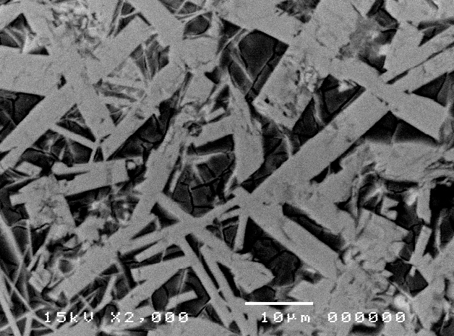
Figure 2 Figure caption.
If more of single column table or figure is needed, just simply copy the table or figure box (the dash line box) and paste to the place you want.
REFERENCES
Cited references in text in the order that they appear in the text. The reference must be cited as a number in square brackets (e.g. [1]). Two or more references at a time may be put in one set of brackets (e.g. [3,4], [2-4] or [2,5,6]). Preferred referencing style is as follows;
For journal article;
[1] A. Author, B.Author, The title of the article, Journal abbreviation (italic), published year (Boldface), Volume, page number.
[2] S. Shuman, Structure, mechanism, and evolution of the mRNA capping apparatus, Prog. Nucleic Acid Res. Mol. Biol., 2000, 66, 1-40.
[3] P. Chomczynski, N. Sacchi, Single-step method of RNA isolation by acid guanidinium thiocyanate-phenol-chloroform extraction, Anal. Biochem., 1987, 162, 156-159.

For text book;
[4] A. Author, B.B. Author, C. Author, Book title (Italic), Edition , Publisher, Place of publication, Published year.
[5] J. Sambrook, E.F. Fitsch, T. Maniatis, Molecular Cloning: A Laboratory Manual, second ed., Cold Spring Harbor Press, New York, 1989.

For a chapter in text book;
[6] A. Author, B. Author, Chapter title, in: C. Editor, D. Editor (Eds.), Book title, Publisher, Place of publication, Published year, pp. page(s).
[7] S. Wessely, F. Wood, Treatment the paper title, in: E. Godlee, F. Jefferson (Eds.), Peer Review in Health Sciences, Elsevier, New York, 1979, pp. 222-234.
[8] G.R. Mettam, L.B. Adams, How to prepare an electronic version of your article, in: B.S. Jones, R.Z. Smith (Eds.), Introduction to the Electronic Age, E-Publishing Inc., New York, 1999, pp. 281-304.

